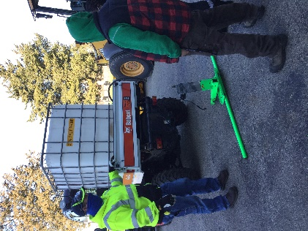
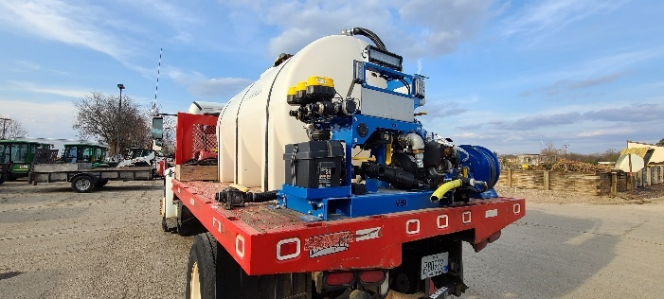
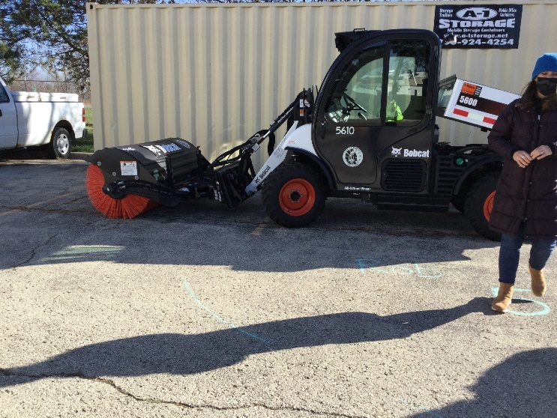
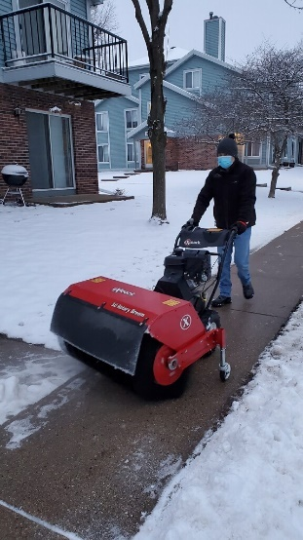
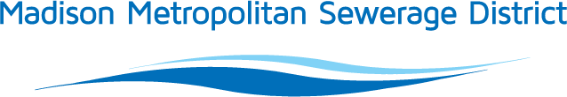
Road Salt Reduction Equipment Grant
PROGRAM INFORMATION
Madison Metropolitan Sewerage District is seeking leaders in winter maintenance! This grant is intended for aspiring leaders in the winter maintenance and snow removal profession – those who are working to reduce salt use on roadways, sidewalks, driveways and parking lots. This grant is intended to assist with purchase of equipment, (new or used) or retrofit existing equipment to facilitate best management practice adoption and reduce salt use. Total available funding per year is expected to be $50,000. The District will consider applications as long as this funding is available.
ELIGIBILITY
Entities that meet all the following criteria are eligible to apply for this grant:
- Work within the District’s service area;
- Have at least one employee who has attended a winter maintenance training class that includes information about the environmental impacts of salt (all City of Madison Salt Certification classes & WI Salt Wise classes count toward this requirement).
- Committed to reducing salt use in winter maintenance practices; and
- Have a written document, such as a winter maintenance policy or a contract (examples linked) that state how and when your organization handles weather events. The policy should include things like:
  - procedures that will occur leading up to, during and after a winter event,
  - the order procedures will occur (ie. which areas are priority)
  - outline of level of service and expectations
THIS GRANT FUNDS…
New or used equipment (including equipment purchase, parts, install/retrofit fees, calibration) that facilitates meeting (or exceeding) Dane County Application Rate Guidelines, and/or an overall decrease in salt use. Funding requests should align with accepted best management practices. Examples include equipment that:
- improve physical snow/ice removal, like rotary brooms (bushes) or enhanced plow blades
- reduces salt application rates, such as brine application booms or drop spreaders
- increases precision of salt application, as in the case of GPS ground speed control, pre-wetting equipment, calibrations, and equipment retrofits
The purpose of providing this incentive is to accelerate adoption of equipment that reinforces best management practices and results in reduced salt use. A primary goal is to aid in situations where cost is a primary barrier to using equipment that yields reduced salt application rates. This grant typically does not cover routine operational maintenance such as running/operating plows, however special cases where quantifiable salt savings can be demonstrated may be considered.
This grant will not fund any purchase of chloride-containing products or brine makers, and will not retroactively fund equipment purchase. Past purchases will not be considered for grant funding.
Any equipment that applies chloride deicing products must include information about application rate both during application and at the time of invoicing for grant award.
REQUIREMENTS
Grant awardees are expected to:
- Complete a salt reduction project in District’s service area.
- Demonstrate a measurable decrease in salt use.
- Install/complete between time of application and the following spring season.
- Share project experience. Grant recipients will be required to provide photos and other documentation for developing a case study or public outreach efforts.
- Submit completed final report including salt application data.

EXAMPLES
More information is available on the Chloride page of the District’s website. Case studies from previous awardees are available on the Wisconsin Salt Wise website.

AWARD AMOUNT
Requested grant funds shall not exceed half, 50% of total capital investment needed for the project. Typical awards range $500-$12,000 per applicant.

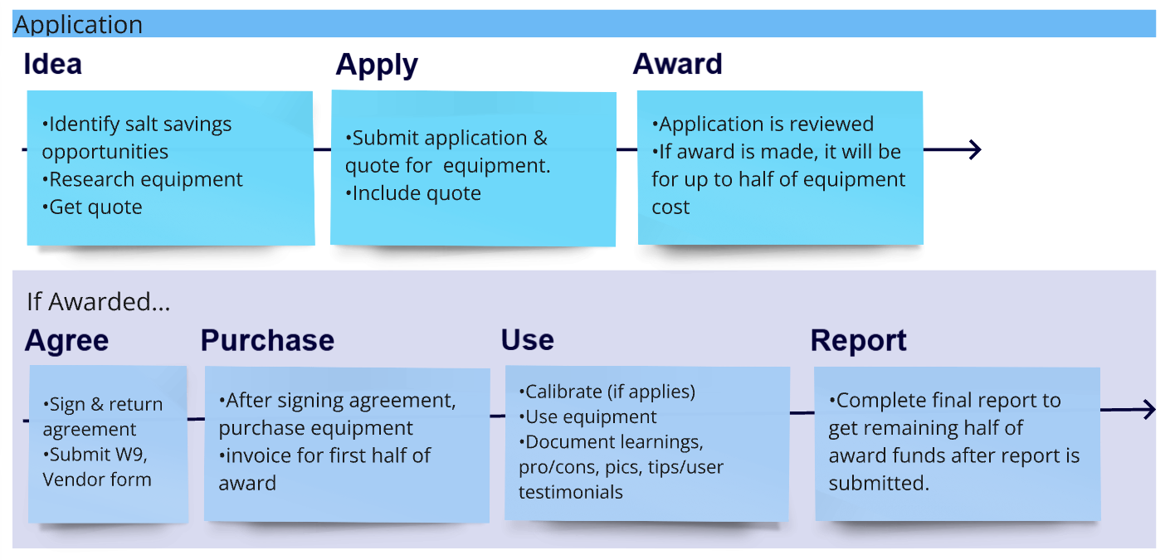
PROCESS
The Road Salt Reduction Equipment Grant will not support purchases retroactively. Applicants may not submit grant applications for equipment that has already been purchased.

APPLICATION EVALUATION
Applications will be primarily evaluated on the thoroughness and completeness of submitted application materials. Projects that will receive priority are those with clear, reasonable timelines and budgets; on sites in visible areas with educational value; and contain measurable results and have clear goals in line with the purpose of this grant. Additional consideration will be given to projects that are able to prove a change in salt use with strong quantifiable data.
Applications will generally take at least two weeks to review; applicants should not expect quicker turnaround. District staff may seek additional clarifying questions as part of the application review process. Applications on which questions remain unanswered by the applicant for more than 2 months will be considered closed. If applications are closed, applicants may re-apply.

REPORTING
Final reporting information must include the following:
- Estimate of salt reduction as a result of the new equipment;
- Description of the method for measuring the reduction;
- Summary of knowledge gained through the pilot grant program;
- Assessment of the new equipment – speak to the ease (or challenges) experienced when using the equipment
- Recommendations for other practitioners who might employ similar practices or equipment in the future;
- Pictures of grant-funded equipment.

The application and final reporting template include prompts to help applicants provide this information.

REIMBURSEMENT
Up to half of the total award amount, not to exceed half of the total project cost, can be reimbursed at the outset of the project, based on invoices provided by awardee. The remainder of the award funds will be reimbursed when the grant recipient provides final reporting information. Total project cost will be determined based on sales receipts provided to the District.

DEADLINE
Applications will be reviewed in the order in which they are received until funding is exhausted annually. The District reserves the right to consider special awards in the best interest of the overall chloride reduction program.

Madison Metropolitan Sewerage District
Road Salt Reduction Grant - APPLICATION
Complete applications, including this application form and relevant attachments, should be sent to pp@madsewer.org with subject line, “Road Salt Reduction Grant Proposal.” Grants will be considered in the order in which they are received.
Note: There is no limit to length of this application; please provide attachments and use more space to answer questions as necessary.
- Eligibility and contact information
Please complete this section fully, including checking yes or no for items a) through f).
Applicant Name
(organization):
Contact Name
Contact Title
Mailing Address
Email Address
Phone Number(s)

 |  | Yes | No
a) | Will the project occur in the District’s service area? (Provide map or locations) | ☐ | ☐
b) | Are you willing to provide access to your test site(s) for video, photos, or interviews regarding this project? | ☐ | ☐
c) | Are you willing to share information about this project to aid the District’s public outreach efforts (pictures, data for case studies, short videos)? | ☐ | ☐
d) | Are you willing to accept partial funding for this project? | ☐ | ☐
e) | Do you have, or will you develop, a winter maintenance policy? | ☐ | ☐
f) | Applicant (or at least one employee) has attended winter maintenance training with an environmental component (specifically chloride pollution). | ☐ | ☐
g) | Will this project proceed without grant funding? | ☐ | ☐
2. Company background and project description:
Provide a broad description of the company and reason for application to this grant program.

3. Current Practices:
What are your current de-icing/salting practices. Please attach a copy of your winter maintenance policy, or standard contract (any document that describes where, when and how deicers are currently used).

4. Challenges to salt reduction:
What are the greatest challenges for individuals in your organization to reduce salt use?

5. Proposed activities for grant-funded project:
Tell us the equipment you plan to purchase and the specific actions that will reduce salt use. Please be specific about how this equipment purchase will save your company salt and/or how experiences from this project can be transferred to others. If the equipment applies any deicing chemical, include information about the application rate capabilities and plan for calibration.

6. Anticipated results:
What do you estimate reduction in salt use to be as a result of this project? How do you plan on measuring reduction in salt use, changes in management, behavior or social norms throughout the course of the project?

7. Project timeline:
Please outline the timeline for ordering equipment, starting to use it and any other relevant details.

8. Outreach & Education:
Describe outreach and education you will do as part of using this new equipment (could be education of operators, clients/building users, signage, email notices, trainings, for example).

9. Implementation address(s) or relevant maps (provide attachments as necessary). Grant funded equipment must be used within the District’s service area:

10. Project budget
Please provide an itemized summary of project expenses. Attach product quotes to this application. Grant funds cannot be used to support purchase of chloride containing products.
Item | Cost

Total project cost $________
Requested support from the District $________ (up to 50 percent of total capital expenditure)

Madison Metropolitan Sewerage District
Road Salt Reduction Grant – REPORTING
After the project is complete, submit this completed questionnaire and a final invoice for remaining award funds disbursement. This report should be completed by the date specified in the award agreement. Extensions may be granted ahead of time in writing. Detailed information helps inform future improvements to this grant and builds case studies that can be shared with others in the region.

- What do you consider the greatest successes of this project?

- What did you consider the greatest challenges or opportunities for improvement?

- How did your practices change as a result of this project? How do you intend to continue reducing salt use practices in the future? (Which practices will you continue? Which new ones will you add? What resources will you need?)

- Did this project lead to reduced salt use? Please provide an estimate of reductions this year, including information about how you calculated that estimate.
Winter season (years): | Winter season (years): | Winter season (years): | Current season – to be provided as part of grant reporting.

- How do you intend to continue reducing salt use practices in the future? (Which practices will you continue? Which new ones will you add? What resources will you need?)

- Did you experience any challenges using this funding program?

- Please attach pictures of the grant-funded equipment.

